Sweet St Poem Co
bc canada
604 616 8225
info@sweetstpoemco.com

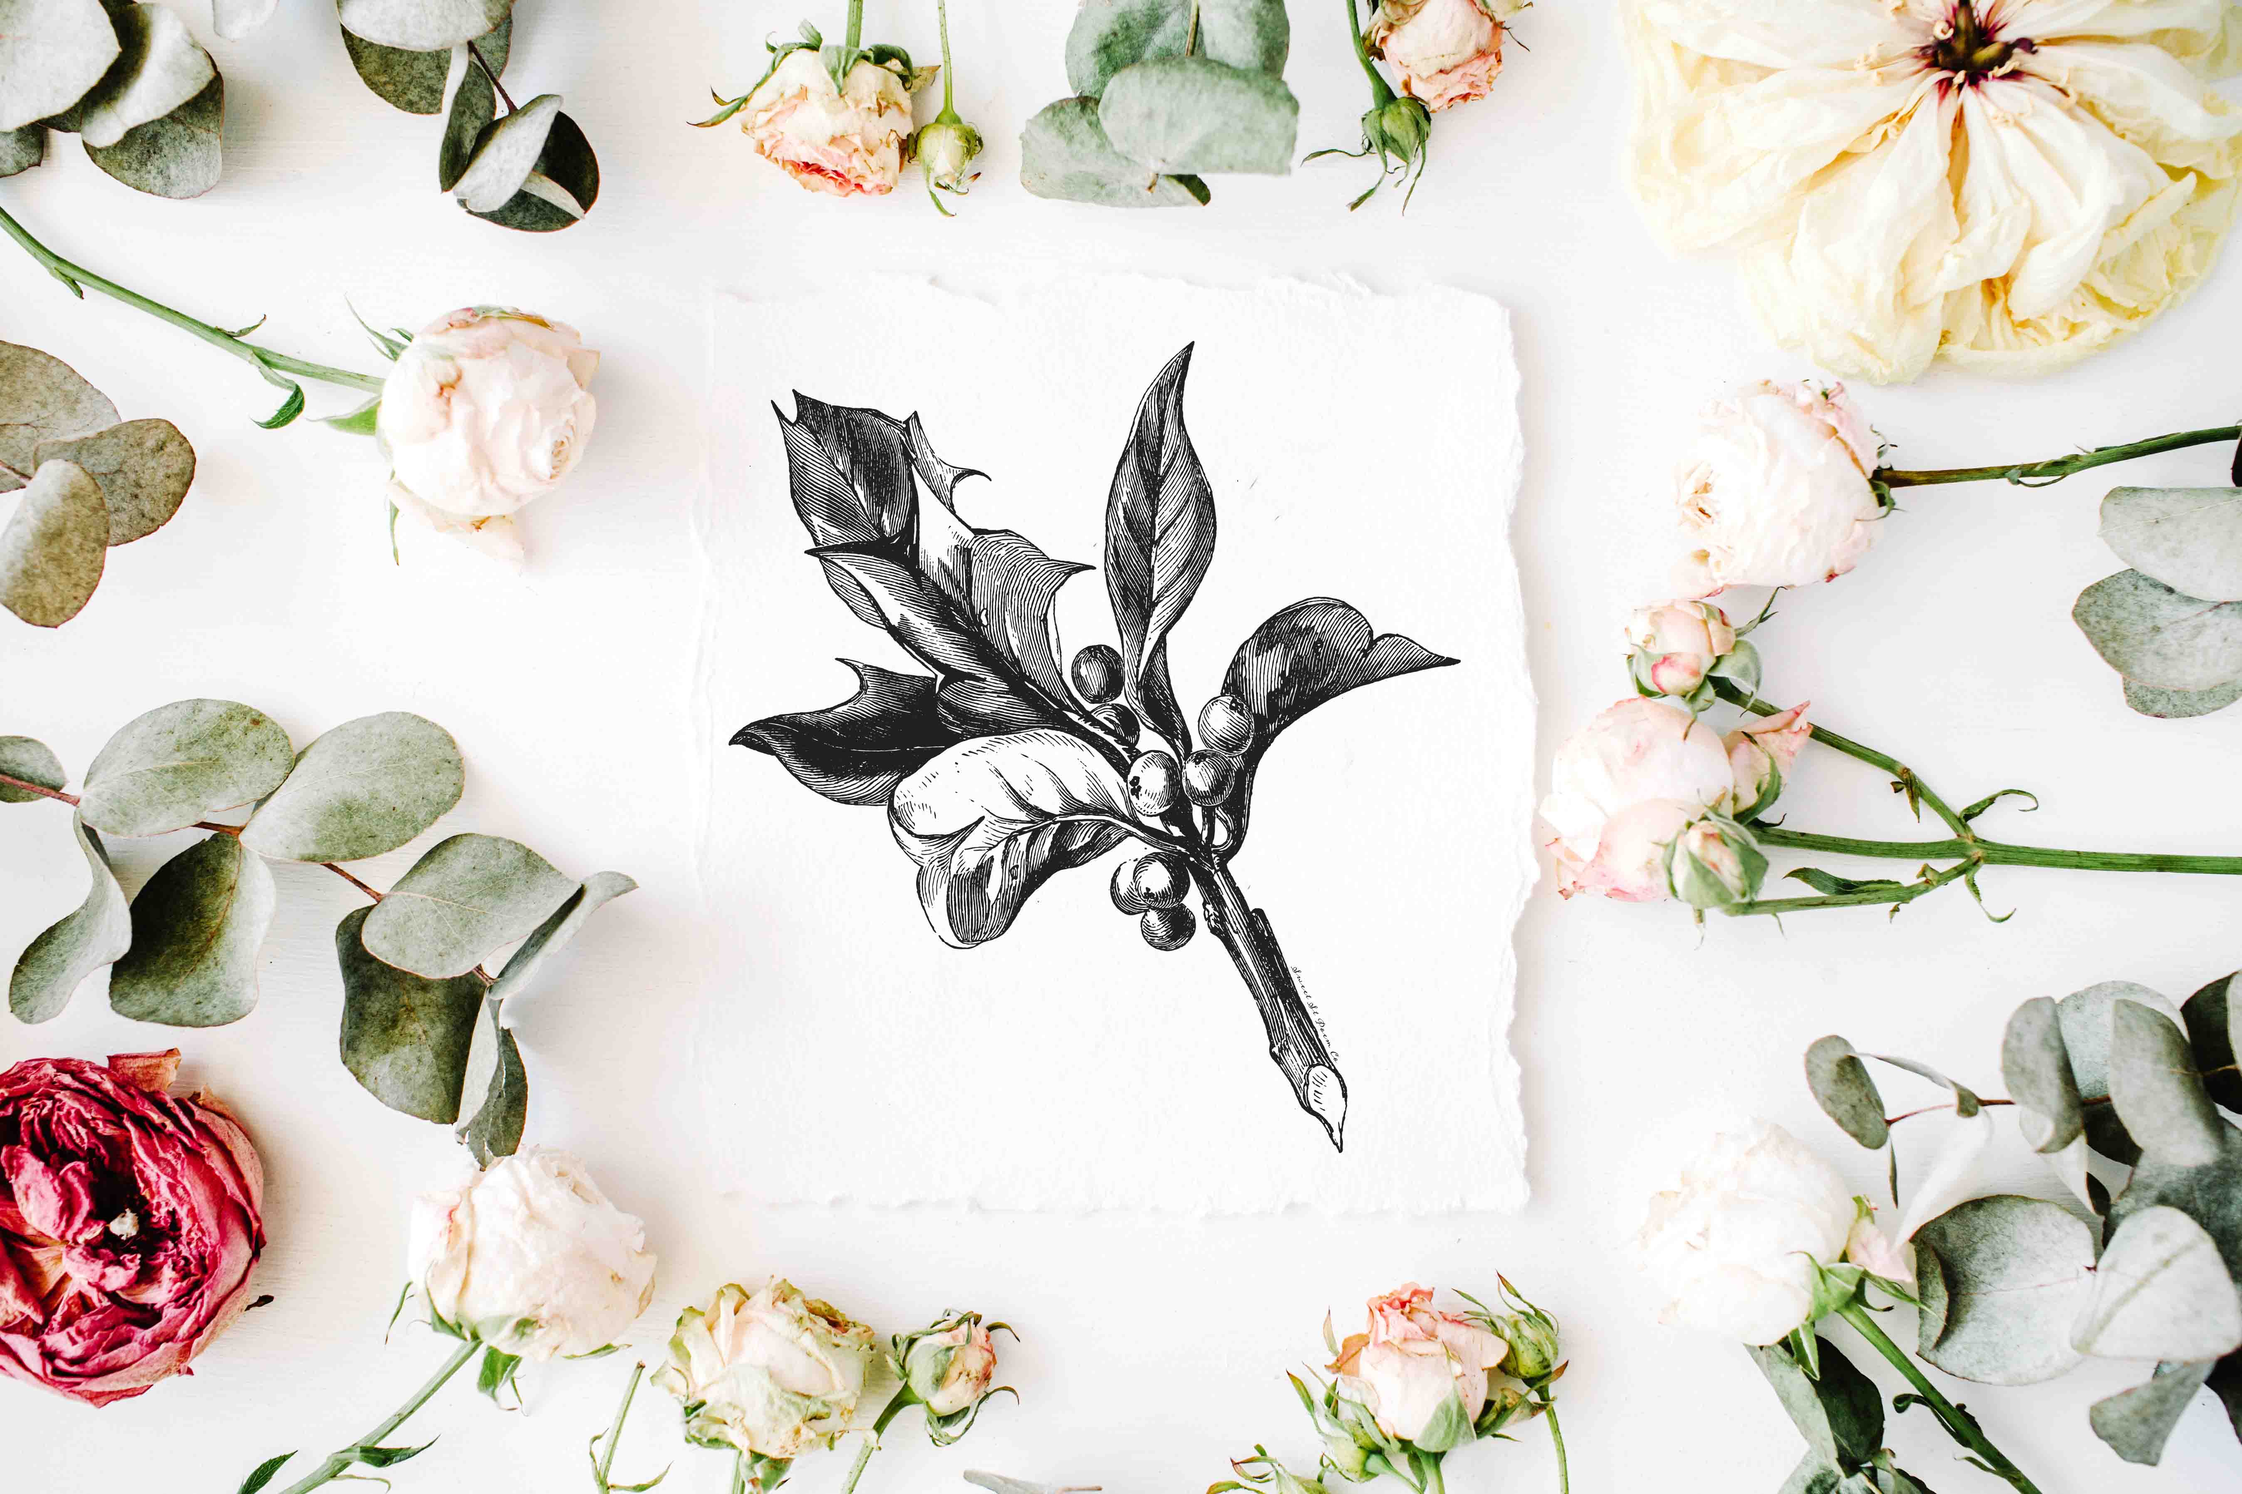
2019 PRICELIST
IN CANADIAN FUNDS
(SHIPPING, DUTIES & TAXES
TO BE PAID BY PURCHASER.)

Vintage Collection.
SINGLE COLOUR ITEM PRICED PER CARD | PER 1000 | PER 5000 | PER 10 000
5X5 FOLDED UNPRINTED | 1.30 | 1.30 | 1.30
5X5 OR 5X7 FOLDED PRINTED | 1.60 | 1.60 | 1.60
5X5 OR 5X7 ENVELOPE | 1.30 | 1.30 | 1.30
FULL COLOUR ITEM
5X5 OR 5X7 FOLDED PRINTED | 1.80 | 1.80 | 1.80
5X5 OR 5X7 ENVELOPE | 1.30 | 1.30 | 1.30
Handmade papers

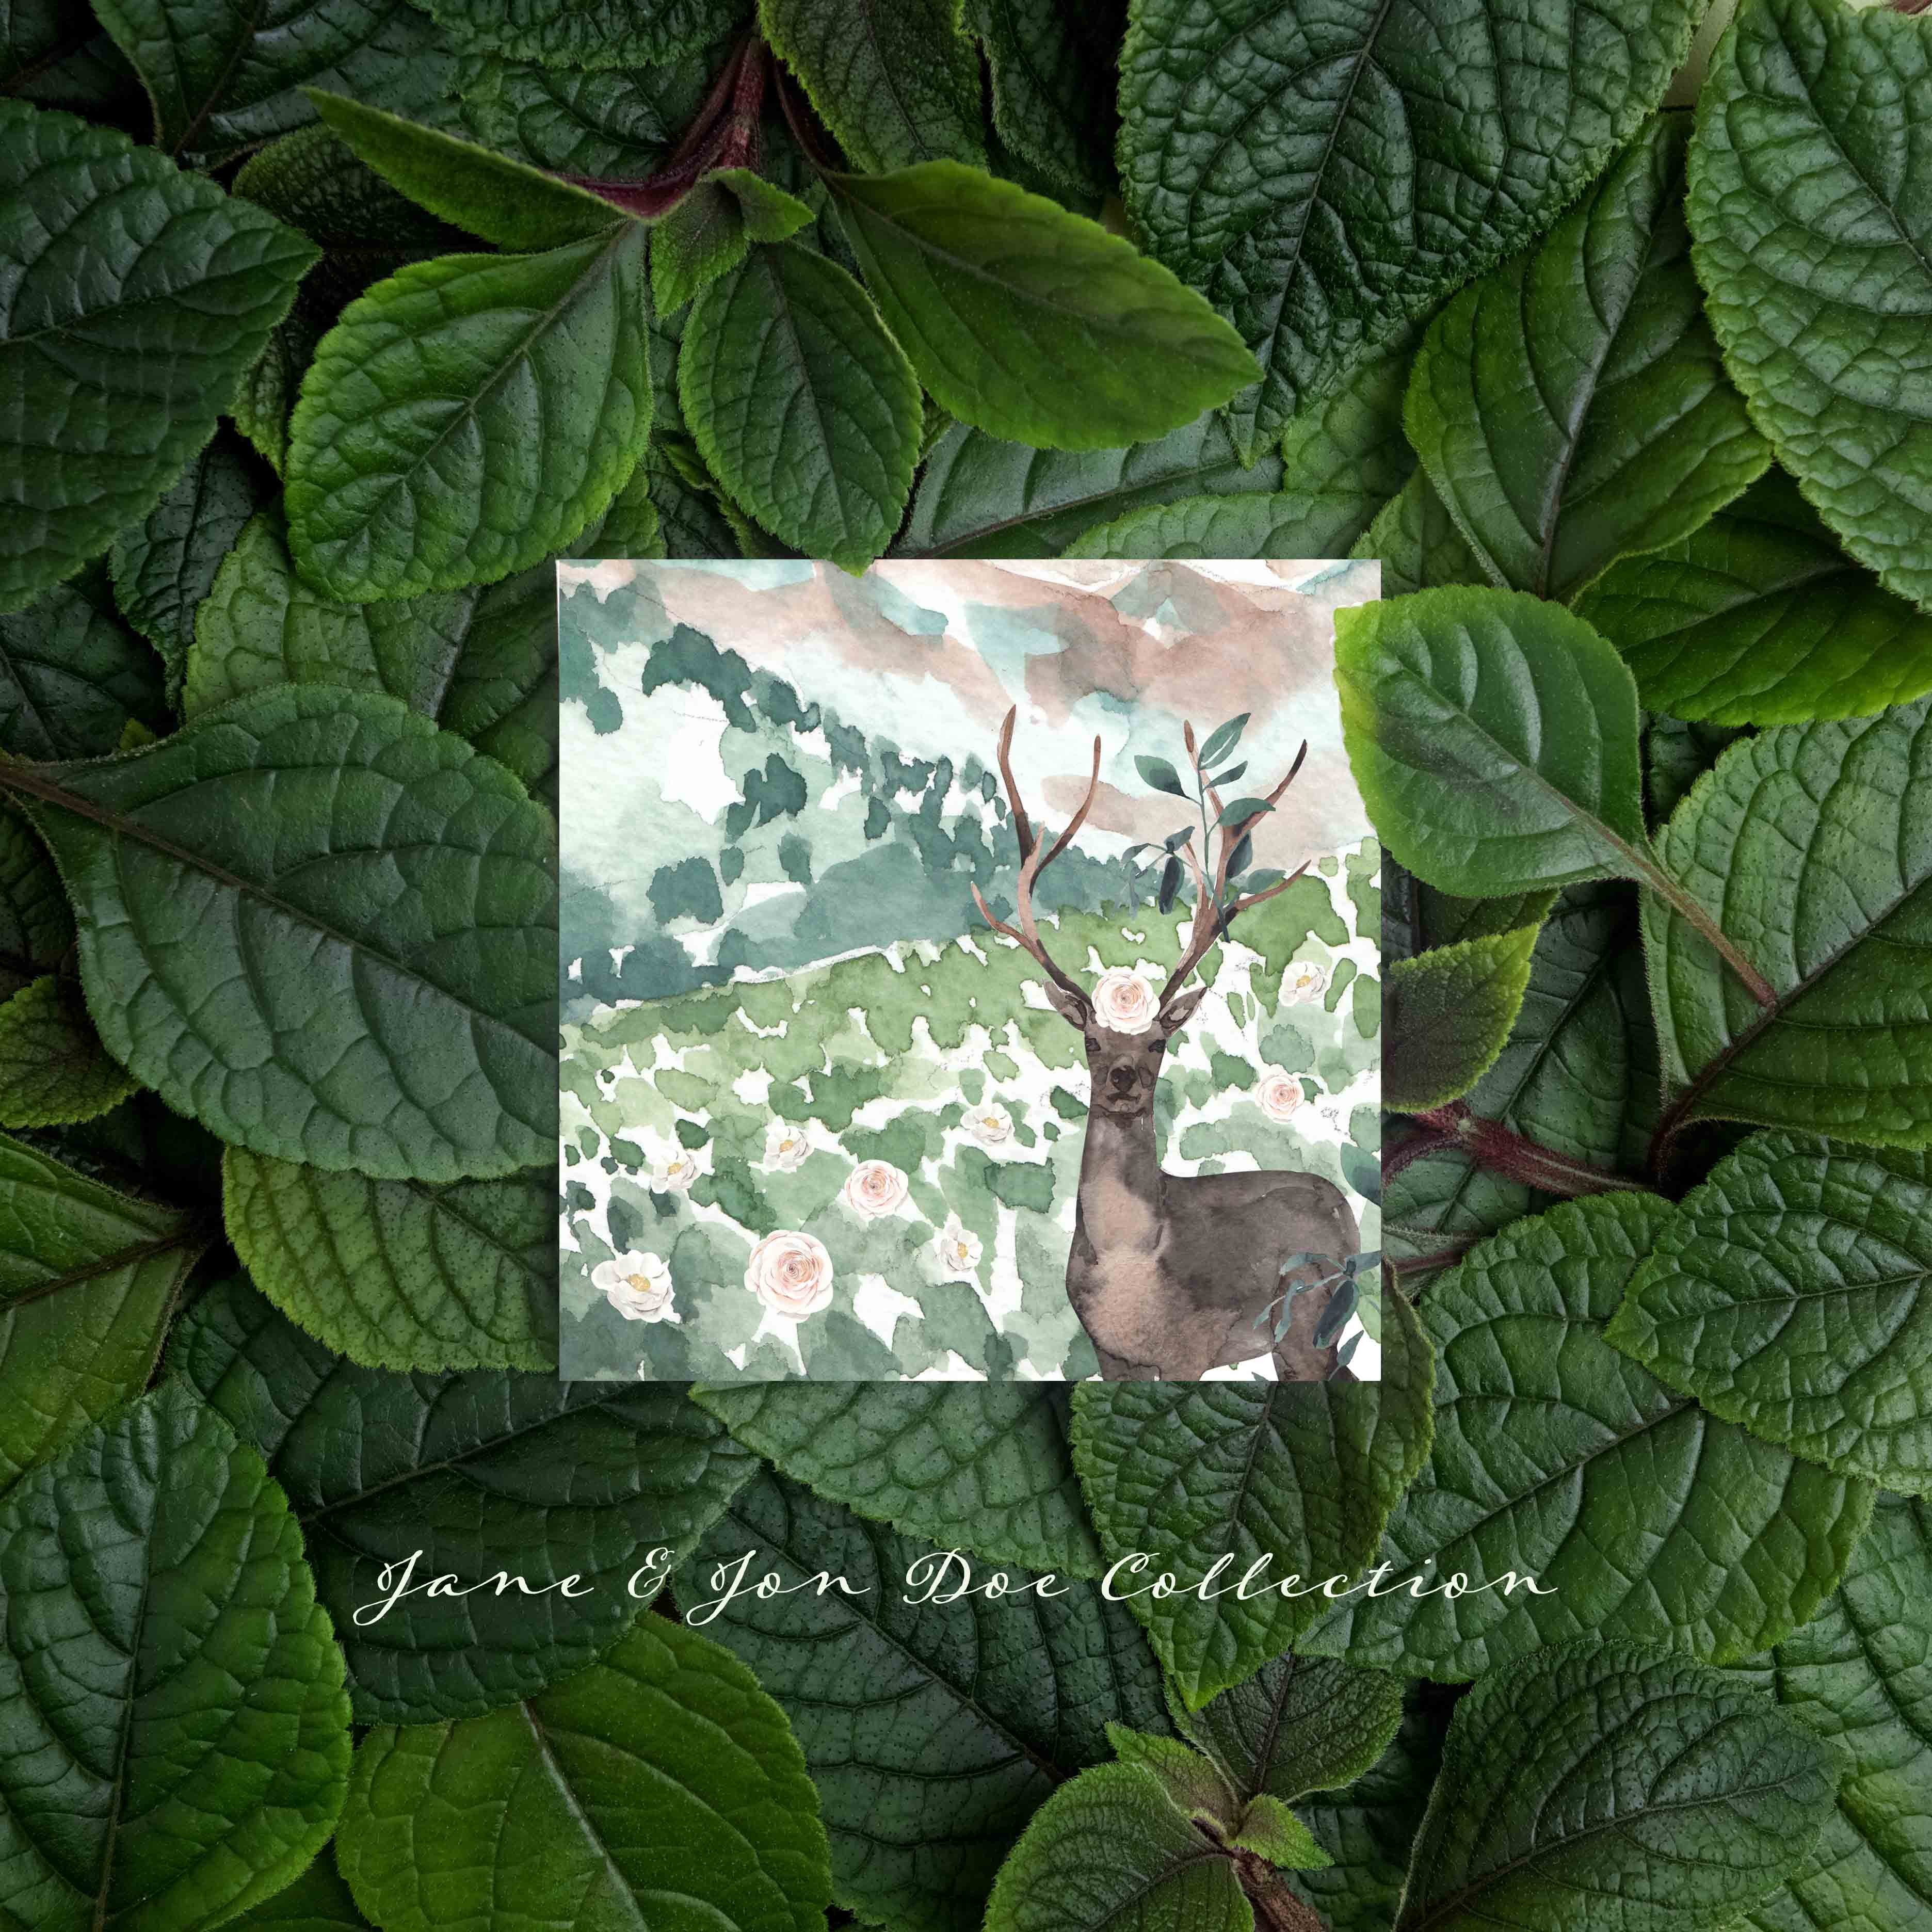

ALL COLLECTIONS AVAILABLE ON LUXURY CARD STOCK.

LUXURY CARDS
LUXURY CARD STOCK | PER 25 CARDS | INDIVIDUAL CARD VALUE | RESALE VALUE OF EACH CARD APPROX.
5X5 0R 5X7 FOLDED OR FLAT | 78.00 | 3.12 | 12.95
5X5 OR 5X7 ENVELOPES | 12.00 | 0.48
5X5 OR 5X7 FOIL PRINT CARDS FOR CALLIGRAPHY ADDRESSING AND HANDWRITTEN INVITATIONS | 80.00 | 3.20 | 13.95
100 % RECYCLED FSC CERTIFIED PAPERS.

*FOIL PRINT CARDS AVAILABLE IN ROSE GOLD, GOLD AND SILVER FOIL. MATCHING ENVELOPES AVAILABLE.

STANDARD CARDS
80% Post consumer recycled product

 | 100 | 500 | 1000 | 2500 | 5000 | 10 000
8.5 x 11 Inches  With envelopes | 2.72 | 2.00 | 1.90 | 1.50 | 1.25 | 0.75

 | 100 | 500 | 1000 | 2500 | 5000 | 10 000
5.5 x 8.5 Inches  With envelopes | 1.85 | 1.05 | 0.95 | 0.92 | 0.90 | 0.42

MINI CARDS WITH ONE DESIGN ONLY | 100 | 250 | 500
100% Recycled Card Stock | 99.00 | 135.00 | 178.00
GLOSS OR FOIL TECHNIQUE CARDS | 120.00 | 160.00 | 180.00
Mini cards

MINI CARDS WITH AN ASSORTMENT OF FIVE DESIGNS WITHIN A THEME | 100 | 250 | 500
100% Recycled Card Stock | 130.00 | 150.00 | 180.00
GLOSS, FOIL & MATTE DESIGN | 150.00 | 170.00 | 199.00

MINI CARD ENVELOPES | 100 | 250 | 500
STANDARD | 10.00 | 20.00 | 38.00
ARTISAN | 40.00 | 80.00 | 125.00

